ELEC 374 CPU Design – Phase 1

David-Alexandre Edwards (20099471),

Elan Bibas (20099396),

Hannah Berthiaume (20114482)

# Verilog Code

## Register.v

module register(input clock, input clear, input enable, input [31:0] BusMuxOut, output [31:0] BusMuxIn);

reg [31:0] q;

// Behavioral section for writing to the register

always @ ( posedge clock)

begin

if(clear) begin

q <= 32'b0;

end

else if(enable) begin

q <= BusMuxOut;

end

end

assign BusMuxIn = q;

endmodule

## MDR.v

module MDR(

input clk, clear, MDRin, read,

input [31:0] BusMuxOut,

input [31:0] Mdatain,

output [31:0] BusMuxInMDR

);

// Behavioral section for writing to the register

reg [31:0] Din;

reg [31:0] In;

always @ (posedge clk)

begin

if (read) begin

Din <= Mdatain;

end

else begin

Din<= BusMuxOut;

end

if(clear) begin

In <= 32'b0;

end

else if(MDRin) begin

In <= Din;

end

end

assign BusMuxInMDR = In;

endmodule

## BoothMulti.v

module boothmult(output [63:0] result,input signed [31:0] X,input signed [31:0] Y);

reg [2:0] cc[(32 / 2)-1:0];

reg [32:0] pp[(32 / 2)-1:0];

reg [32*2-1:0] spp[(32 / 2)-1:0];

reg [32*2-1:0] product;

wire [32:0] inv_X;

integer k,i;

assign inv_X = {~X[31], ~X} + 1;

always @ (X or Y or inv_X)

begin

cc[0] = {Y[1],Y[0],1'b0};

for(k=1;k<(32 / 2);k=k+1)

cc[k] = {Y[2*k+1], Y[2*k], Y[2*k-1]};

for(k=0;k<(32 / 2);k=k+1)

begin

case(cc[k])

3'b001 , 3'b010 : pp[k] = {X[32-1],X};

3'b011 : pp[k] = {X,1'b0};

3'b100 : pp[k] = {inv_X[32-1:0],1'b0};

3'b101 , 3'b110 : pp[k] = inv_X;

default : pp[k] = 0;

endcase

spp[k] = $signed(pp[k]);

for(i=0;i<k;i=i+1)

spp[k] = {spp[k],2'b00};

end

product = spp[0];

for(k=1;k<(32 / 2);k=k+1)

product = product + spp[k];

end

assign result = product;

endmodule

## ALU.v

module ALU(

input [4:0] aluControl,

input [31:0] BusMuxInY,

input [31:0] BusMuxOut,

output [31:0] Zlowout,

output [31:0] Zhighout

);

//have two outputs instead

reg [31:0] COut;

reg [31:0] temp;

reg [31:0] temp1;

reg [31:0] temp2;

wire [63:0] ZOut;

integer i;

boothmult Mult(ZOut, BusMuxInY, BusMuxOut);

always @ (aluControl) begin

temp1 = BusMuxOut;

temp2 = BusMuxInY;

if(aluControl == 5'b00011) begin //Add

COut = BusMuxInY + BusMuxOut;

end

else if(aluControl == 5'b00100) begin //Sub

COut = BusMuxInY - BusMuxOut;

end

else if(aluControl == 5'b00101) begin //Shift Right

for (i = 0 ; i < 31 ; i = i + 1) begin

COut[i] = BusMuxInY[i+1];

end

COut[31] = 0;

end

else if(aluControl == 5'b00110) begin //Shift Left

for (i = 1 ; i < 32 ; i = i + 1) begin

COut[i] = BusMuxInY[i-1];

end

COut[0] = 0;

end

else if(aluControl == 5'b00111) begin //Rotate Right

for (i = 0 ; i < 31 ; i = i + 1) begin

COut[i] = BusMuxInY[i+1];

end

COut[31] = BusMuxInY[0];

end

else if(aluControl == 5'b01000) begin //Rotate Left

for (i = 1 ; i < 32 ; i = i + 1) begin

COut[i] = BusMuxInY[i-1];

end

COut[0] = BusMuxInY[31];

end

else if(aluControl == 5'b01001) begin //AND

//loop with for loop, then use logial and for each bit

for (i = 0 ; i < 32 ; i = i + 1) begin

COut = (BusMuxInY & temp1);

end

end

else if(aluControl == 5'b01010) begin //OR

for (i = 0 ; i < 32 ; i = i + 1) begin

COut[i] = BusMuxInY[i] | BusMuxOut[i];

end

end

else if(aluControl == 5'b01110) begin //Multiply

COut = ZOut[31:0];

temp = ZOut[63:32];

end

else if(aluControl == 5'b01111) begin //Divide

COut = BusMuxInY / BusMuxOut;

end

else if(aluControl == 5'b10000) begin // Negate

for (i = 0 ; i < 32 ; i = i + 1) begin

COut[i] = ~temp1[i];

end

COut[0] = COut[0] + 1'b1;

end

else if(aluControl == 5'b10001) begin // Not

for (i = 0 ; i < 32 ; i = i + 1) begin

COut[i] = ~temp1[i];

end

end

if(aluControl != 5'b01111)

temp = {32{COut[31]}};

// assign the results to z high and z low

end

assign Zhighout = temp; // ZOut[31:0]

assign Zlowout = COut; // ZOut[63:32]

endmodule

// Z register holds the results of the operation in ALU

## Bus.v

module bus(input [31:0] BusMuxInR0, input [31:0] BusMuxInR1, input [31:0] BusMuxInR2, input [31:0] BusMuxInR3,input [31:0] BusMuxInR4,input [31:0] BusMuxInR5,input [31:0] BusMuxInR6,input [31:0] BusMuxInR7,input [31:0] BusMuxInR8,input [31:0] BusMuxInR9,input [31:0] BusMuxInR10,

input [31:0] BusMuxInR11,input [31:0] BusMuxInR12,input [31:0] BusMuxInR13,input [31:0] BusMuxInR14,input [31:0] BusMuxInR15,input [31:0] BusMuxInHi,input [31:0] BusMuxInLo,input [31:0] BusMuxInZHi,input [31:0] BusMuxInZLo,input [31:0] BusMuxInPC,

input [31:0] BusMuxInMDR,input [31:0] BusMuxInRInP,input [31:0] BusMuxInRCSign, input R0out, input R1out,input R2out,input R3out,input R4out,input R5out,input R6out,input R7out,input R8out,input R9out,input R10out,input R11out,input R12out,

input R13out,input R14out,input R15out,input HIout,input LOout,input Zhighout,input Zlowout,input PCout, input MDRout,input InPortout,input Cout, output [31:0] BusMuxOut);

reg [31:0] out;

always @ (BusMuxInR0 or BusMuxInR1 or BusMuxInR2 or BusMuxInR3 or BusMuxInR4 or BusMuxInR5 or BusMuxInR6 or BusMuxInR7 or BusMuxInR8 or BusMuxInR9 or BusMuxInR10 or BusMuxInR11 or BusMuxInR12 or BusMuxInR13 or BusMuxInR14 or BusMuxInR15 or BusMuxInHi or BusMuxInLo or BusMuxInZHi or BusMuxInZLo or BusMuxInPC or BusMuxInMDR or BusMuxInRInP or BusMuxInRCSign or R2out or R4out or MDRout) begin

if(R0out) begin

out = BusMuxInR0;

end

else if(R1out) begin

out = BusMuxInR1;

end

else if(R2out) begin

out = BusMuxInR2;

end

else if(R3out) begin

out = BusMuxInR3;

end

else if(R4out) begin

out = BusMuxInR4;

end

else if(R5out) begin

out = BusMuxInR5;

end

else if(R6out) begin

out = BusMuxInR6;

end

else if(R7out) begin

out = BusMuxInR7;

end

else if(R8out) begin

out = BusMuxInR8;

end

else if(R9out) begin

out = BusMuxInR9;

end

else if(R10out) begin

out = BusMuxInR10;

end

else if(R11out) begin

out = BusMuxInR11;

end

else if(R12out) begin

out = BusMuxInR12;

end

else if(R13out)begin

out = BusMuxInR13;

end

else if(R14out)begin

out = BusMuxInR14;

end

else if(R15out)begin

out = BusMuxInR15;

end

else if(HIout)begin

out = BusMuxInHi;

end

else if(LOout)begin

out = BusMuxInLo;

end

else if(Zhighout)begin

out = BusMuxInZHi;

end

else if(Zlowout)begin

out = BusMuxInZLo;

end

else if(PCout)begin

out = BusMuxInPC;

end

else if(MDRout)begin

out = BusMuxInMDR;

end

else if(InPortout)begin

out = BusMuxInRInP;

end

else if(Cout) begin

out = BusMuxInRCSign;

end

else begin

out = 32'bx;

end

end

assign BusMuxOut = out;

endmodule

## Datapath.v

module DataPath(

input [31:0] MDatain,

input PCout, Zlowout, MDRout, MARin, Zin, PCin, MDRin, IRin, Yin, incPC, Read,

input [4:0] aluControl,

input clock, clear,

input R2In, R2out, R4In, R4out, R5In

);

//define signals that will connect regiters to bus

wire [31:0] BusMuxOut;

wire [31:0] BusMuxInR0;

wire [31:0] BusMuxInR1;

wire [31:0] BusMuxInR2;

wire [31:0] BusMuxInR3;

wire [31:0] BusMuxInR4;

wire [31:0] BusMuxInR5;

wire [31:0] BusMuxInR6;

wire [31:0] BusMuxInR7;

wire [31:0] BusMuxInR8;

wire [31:0] BusMuxInR9;

wire [31:0] BusMuxInR10;

wire [31:0] BusMuxInR11;

wire [31:0] BusMuxInR12;

wire [31:0] BusMuxInR13;

wire [31:0] BusMuxInR14;

wire [31:0] BusMuxInR15;

wire [31:0] BusMuxInZHi;

wire [31:0] BusMuxInZLo;

wire [31:0] BusMuxInPC;

wire [31:0] BusMuxInMDR;

wire [31:0] BusMuxInRinP;

wire [31:0] BusMuxInRCSign;

wire [31:0] BusMuxInRY;

wire [31:0] ALULoOut;

wire [31:0] ALUHiOut;

//instantiate all registers

register R0(clock, clear, R0In, BusMuxOut, BusMuxInR0);

register R1(clock, clear, R1In, BusMuxOut, BusMuxInR1);

register R2(clock, clear, R2In, BusMuxOut, BusMuxInR2);

register R3(clock, clear, R3In, BusMuxOut, BusMuxInR3);

register R4(clock, clear, R4In, BusMuxOut, BusMuxInR4);

register R5(clock, clear, R5In, BusMuxOut, BusMuxInR5);

register R6(clock, clear, R6In, BusMuxOut, BusMuxInR6);

register R7(clock, clear, R7In, BusMuxOut, BusMuxInR7);

register R8(clock, clear, R8In, BusMuxOut, BusMuxInR8);

register R9(clock, clear, R9In, BusMuxOut, BusMuxInR9);

register R10(clock, clear, R10In, BusMuxOut, BusMuxInR10);

register R11(clock, clear, R11In, BusMuxOut, BusMuxInR11);

register R12(clock, clear, R12In, BusMuxOut, BusMuxInR12);

register R13(clock, clear, R13In, BusMuxOut, BusMuxInR13);

register R14(clock, clear, R14In, BusMuxOut, BusMuxInR14);

register R15(clock, clear, R15In, BusMuxOut, BusMuxInR15);

register RHi(clock, clear, RHiIn, BusMuxOut, BusMuxInRHi);

register RLO(clock, clear, RLOIn, BusMuxOut, BusMuxInRLo);

register RZHi(clock, clear, Zin, ALUHiOut, BusMuxInZHi);

register RZLO(clock, clear, Zin, ALULoOut, BusMuxInZLo);

register PC(clock, clear, PCIn, BusMuxOut, BusMuxInPC);

MDR mdr(clock, clear, MDRin, Read, BusMuxOut, MDatain, BusMuxInMDR);

register RInP(clock, clear, RInPIn, BusMuxOut, BusMuxInRInP);

register RCSign(clock, clear, RCSignIn, BusMuxOut, BusMuxInRCSign);

register RY(clock, clear, Yin, BusMuxOut, BusMuxInRY);

//instantiate bus

bus cpuBUS(

BusMuxInR0,BusMuxInR1,BusMuxInR2, BusMuxInR3,BusMuxInR4,BusMuxInR5,BusMuxInR6,BusMuxInR7,BusMuxInR8,BusMuxInR9,BusMuxInR10,BusMuxInR11,BusMuxInR12,BusMuxInR13,BusMuxInR14,BusMuxInR15,

BusMuxInHi,BusMuxInLo,BusMuxInZHi,BusMuxInZLo,BusMuxInPC,BusMuxInMDR,BusMuxInRInP,BusMuxInRCSign,

R0out,R1out,R2out,R3out,R4out,R5out,R6out,R7out,R8out,R9out,R10out,R11out,R12out,R13out,R14out,R15out,

HIout,LOout,Zhighout,Zlowout,PCout,MDRout,INportout,Cout,BusMuxOut

);

ALU alu(aluControl, BusMuxInRY, BusMuxOut, ALULoOut, ALUHiOut);

endmodule

# Testbenches

Each test bench follows a fairly similar process, The only components that change are the T0-T(N) steps. In each case we make sure to change the Mdatain value to represent the correct operator and registers as well as the Operator variable to make sure we are sending the correct operator code to the ALU.

The following is an example of one of our test benches for the AND operation.

`timescale 1ns/10ps

module Tb_add;

reg PCout, Zlowout, MDRout, R2out, R4out;

reg MARin, Zin, PCin, MDRin, IRin, Yin;

reg IncPC,Read, R5in, R2in, R4in;

reg [4:0] Operator;

reg clk;

reg [31:0] Mdatain;

reg clear;

parameter Default = 4'b0000, Reg_load1a= 4'b0001, Reg_load1b= 4'b0010, Reg_load2a= 4'b0011,

Reg_load2b = 4'b0100, Reg_load3a = 4'b0101, Reg_load3b = 4'b0110, T0= 4'b0111,

T1= 4'b1000,T2= 4'b1001, T3= 4'b1010, T4= 4'b1011, T5= 4'b1100;

reg[3:0] Present_state= Default;

DataPath DUT(Mdatain, PCout, Zlowout, MDRout, MARin, Zin, PCin, MDRin, IRin, Yin, incPC, Read, Operator, clk, clear,

R2in, R2out, R4in, R4out, R5in);

initial begin

clk = 0;

forever #10 clk = ~clk;

end

always @(posedge clk) //finite state machine; if clk rising-edge

begin

case (Present_state)

Default : #40 Present_state = Reg_load1a;

Reg_load1a : #40 Present_state = Reg_load1b;

Reg_load1b : #40 Present_state = Reg_load2a;

Reg_load2a : #40 Present_state = Reg_load2b;

Reg_load2b : #40 Present_state = Reg_load3a;

Reg_load3a : #40 Present_state = Reg_load3b;

Reg_load3b : #40 Present_state = T0;

T0 : #40 Present_state = T1;

T1 : #40 Present_state = T2;

T2 : #40 Present_state = T3;

T3 : #40 Present_state = T4;

T4 : #40 Present_state = T5;

endcase

end

always @(Present_state) // do the required job ineach state

begin

case (Present_state) //assert the required signals in each clk cycle

Default: begin

PCout <= 0; Zlowout <= 0; MDRout<= 0; //initialize the signals

R2out <= 0; R4out <= 0; MARin <= 0; Zin <= 0;

PCin <=0; MDRin <= 0; IRin <= 0; Yin <= 0;

IncPC <= 0; Read <= 0; Operator <= 5'b00000;

R5in <= 0; R2in <= 0; R4in <= 0; Mdatain <= 32'h00000000;

clear <= 0;

end

Reg_load1a: begin

Mdatain<= 32'h00000022;

#10 Read <= 1; MDRin <= 1;

end

Reg_load1b: begin

#10 MDRout<= 1; R2in <= 1;

#15 MDRout<= 0; R2in <= 0; // initialize R2 with the value $22

end

Reg_load2a: begin

Read <= 0; MDRin <= 0;

#5 Mdatain <= 32'h00000024;

#10 Read <= 1; MDRin <= 1;

end

Reg_load2b: begin

#10 MDRout<= 1; R4in <= 1;

#15 MDRout<= 0; R4in <= 0; // initialize R4 with the value $24

end

Reg_load3a: begin

Read <= 0; MDRin <= 0;

#2 Mdatain <= 32'h00000026;

#4 Read <= 1; MDRin <= 1;

end

Reg_load3b: begin

MDRout <= 1; R5in <= 1;

#5 MDRout <= 0; R5in <= 0; // initialize R5 with the value $26

end

T0: begin

PCout <= 1; MARin <= 1; IncPC <= 1; Zin <= 1;

end

T1: begin

Zlowout <= 1; PCin <= 1; Read <= 1; MDRin <= 1;

Mdatain <= 32'h4A920000; //opcode for “and R5, R2, R4”

end

T2: begin

MDRout<= 1; IRin <= 1;

end

T3: begin

R2out <= 1; Yin <= 1;

end

T4: begin

R2out <= 0;

Yin <= 0;

R4out<= 1;

#5 Operator <= 5'b01001;

#10 Zin <= 1;

end

T5: begin

R4out <= 0;

Zin <= 0;

Zlowout<= 1; R5in <= 1;

end

endcase

end

endmodule

# Functional Simulation Runs

## Logical And Operation

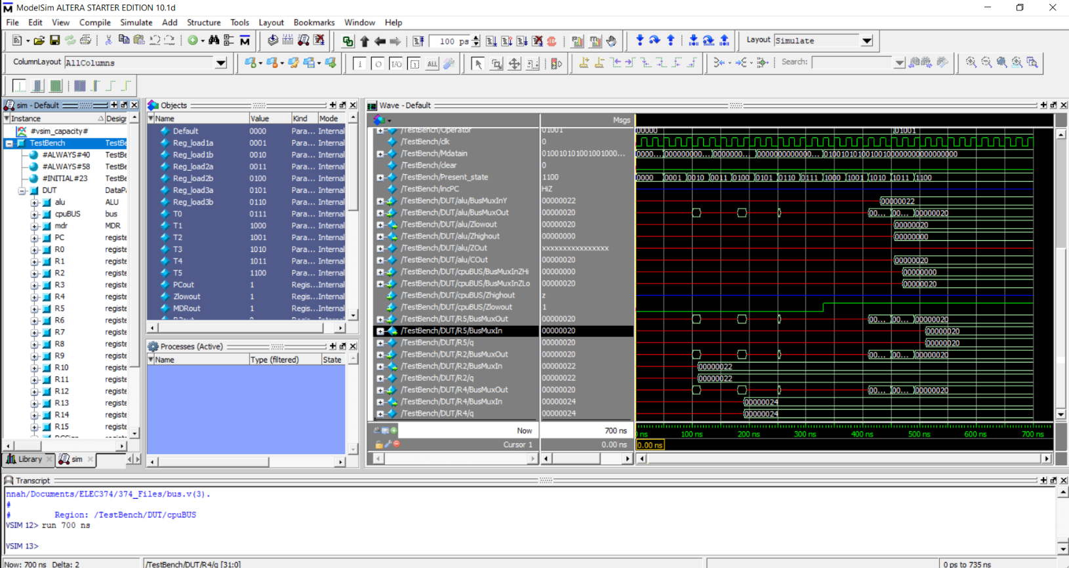

## Logical OR Operation

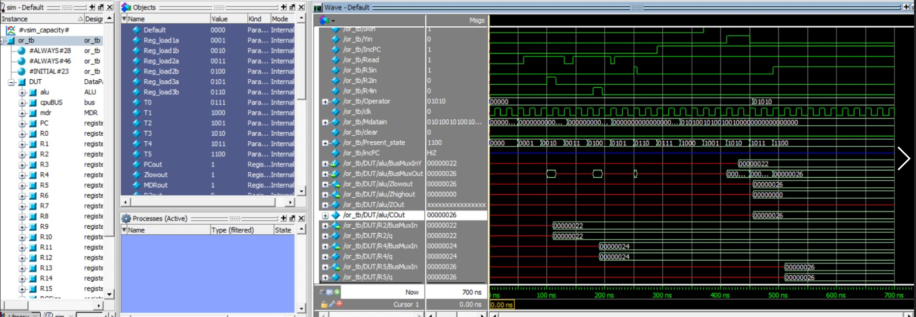

## Multiplication Operation

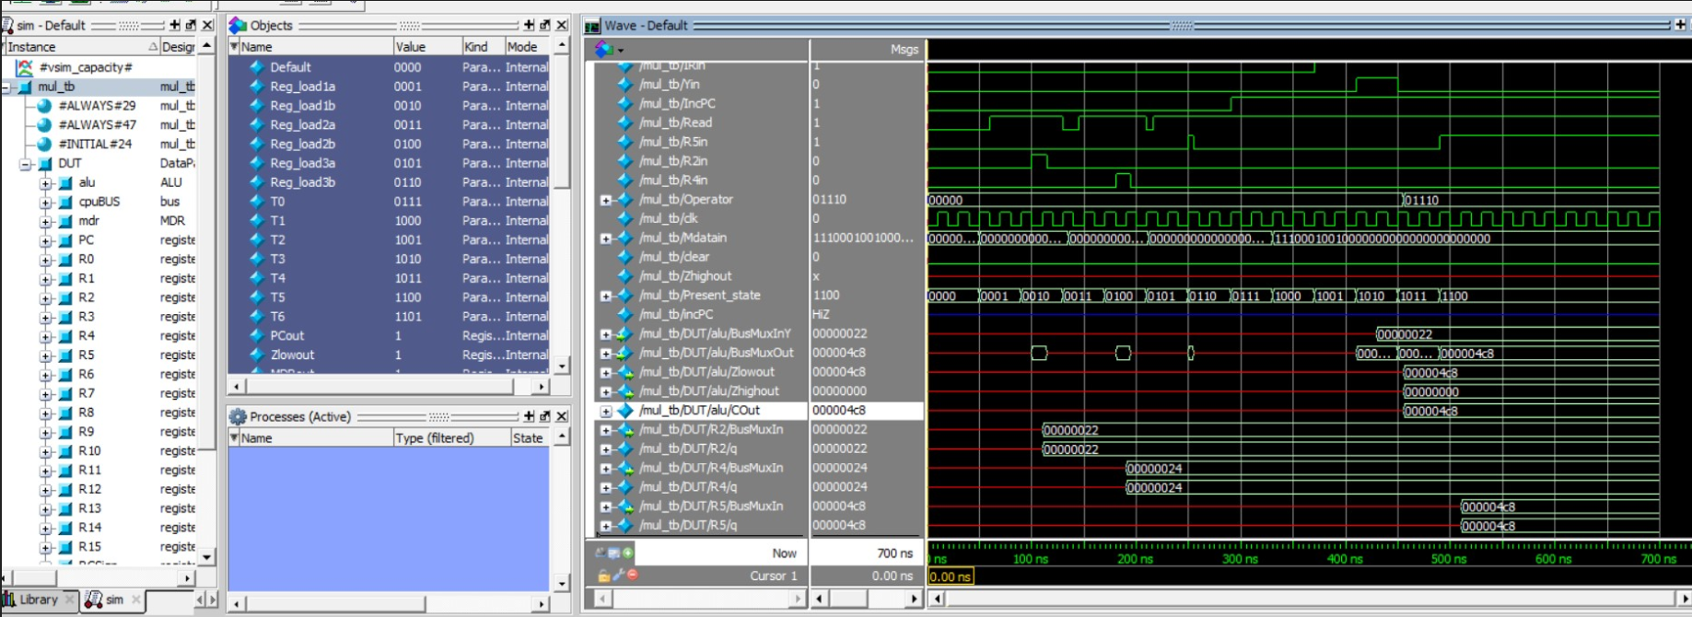

## Division Operation

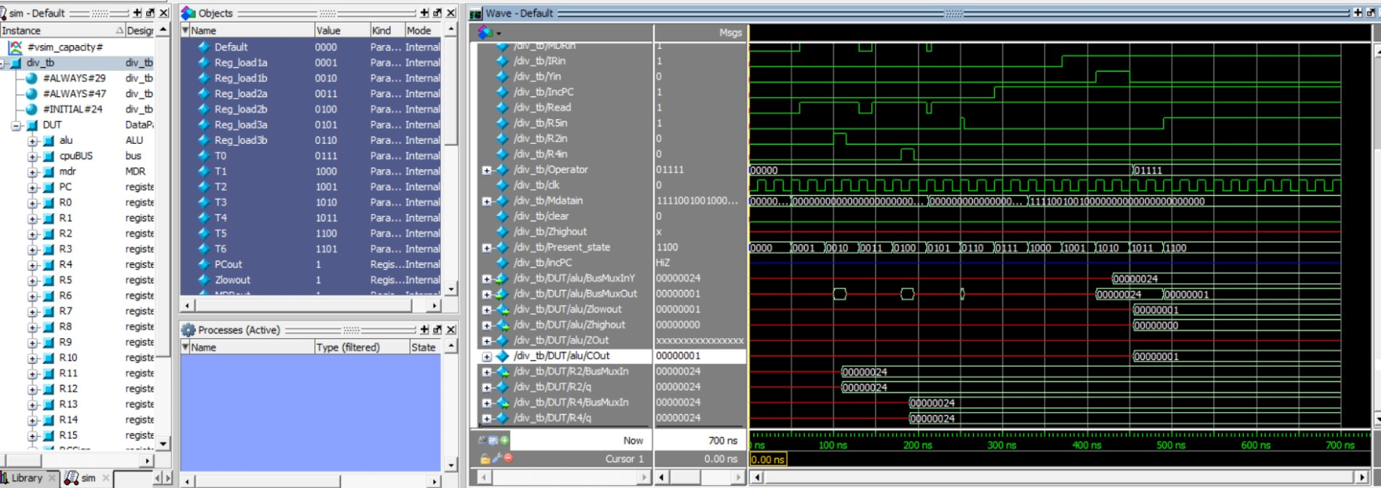

## Add Operation

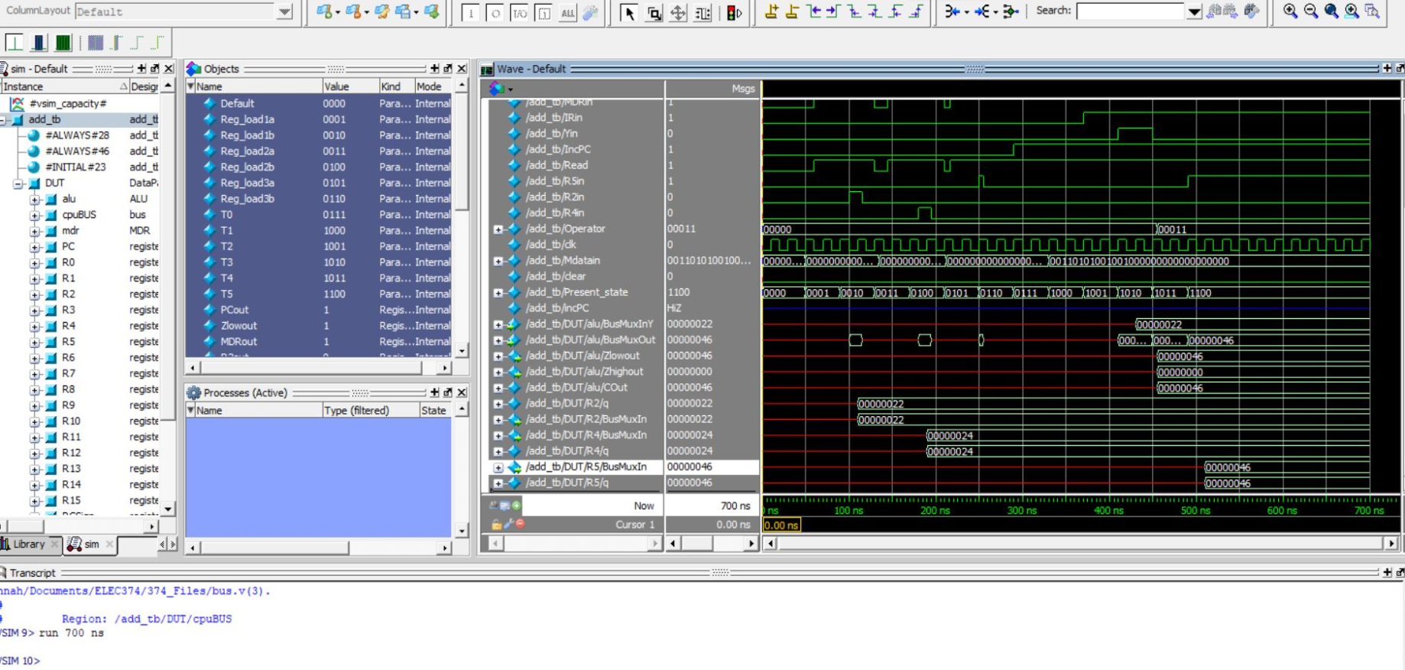

## Subtraction Operation

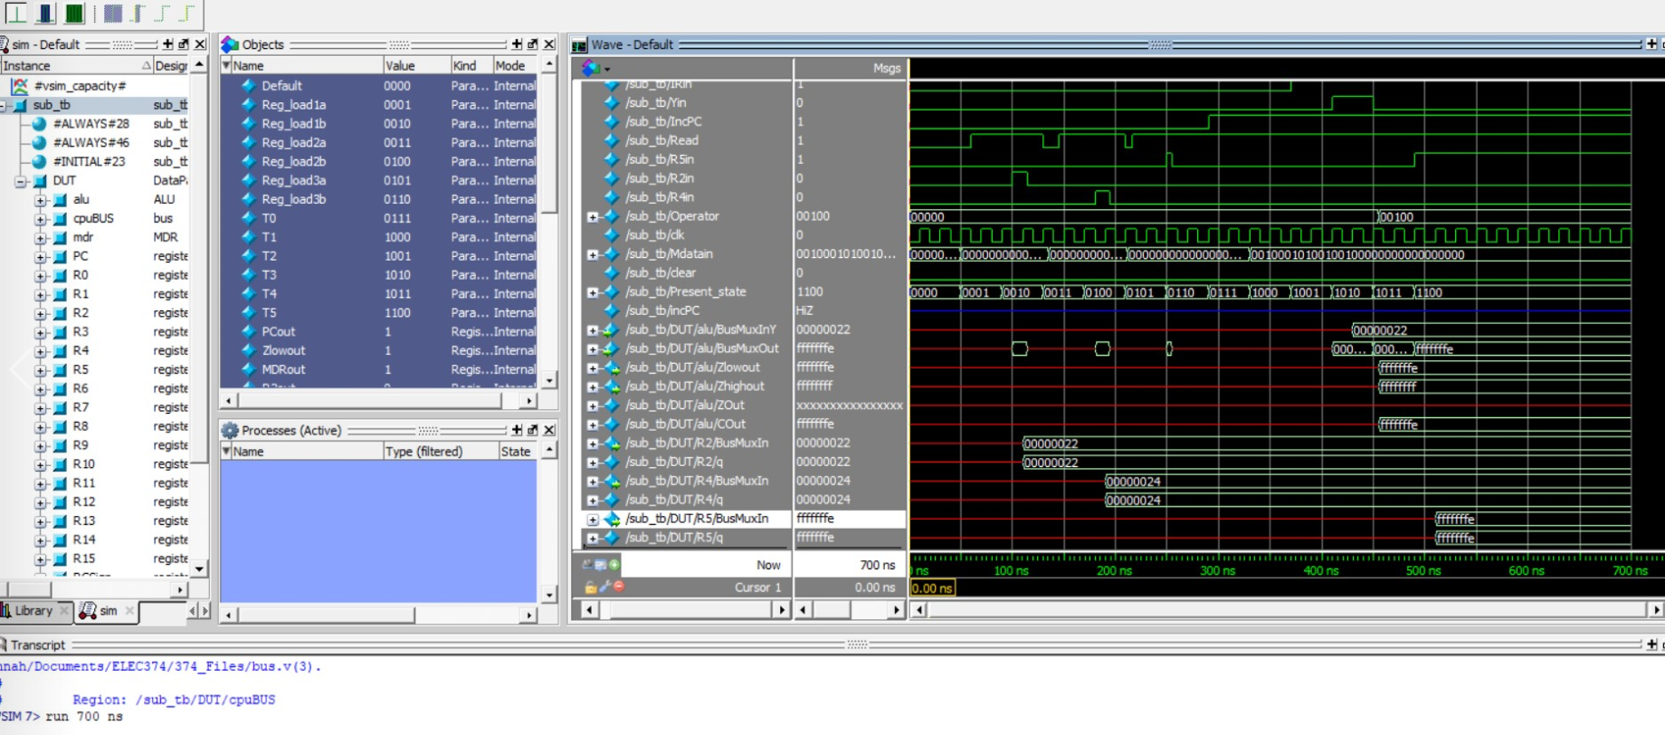

## LSL Operation

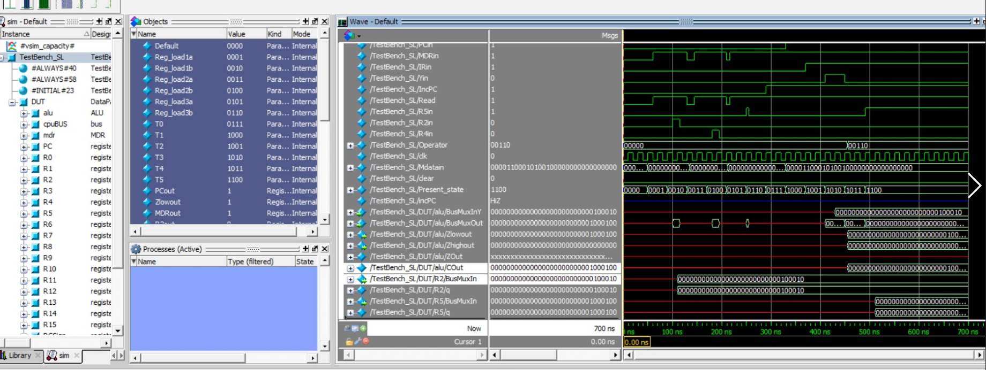

## LSR Operation

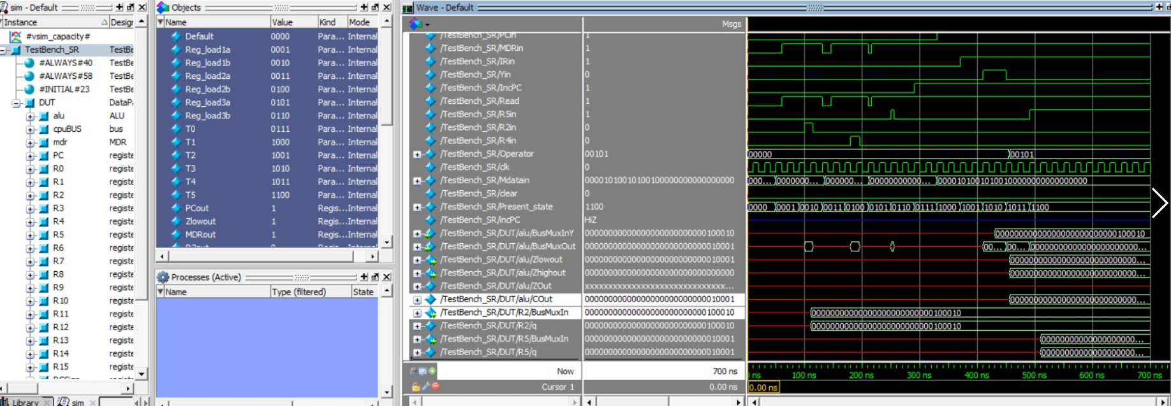

## Rotate Right Operation

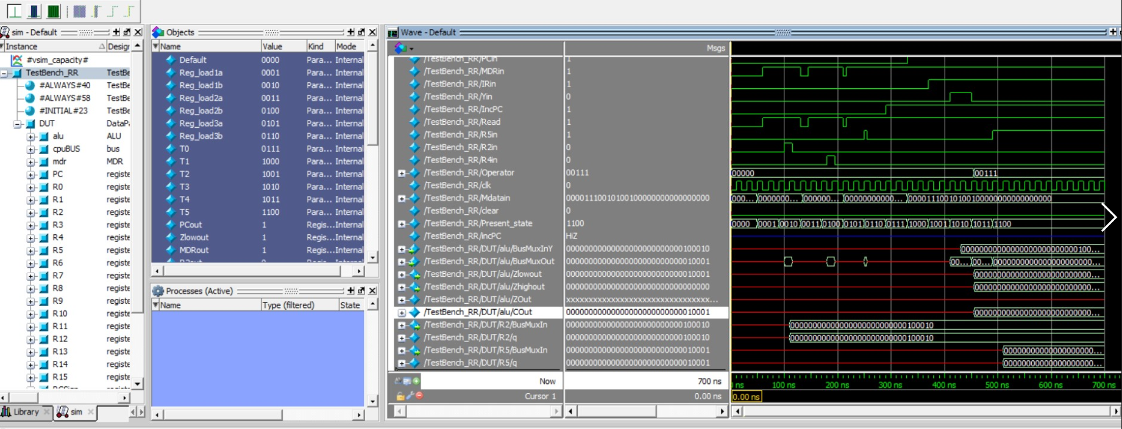

## Rotate Left Operation

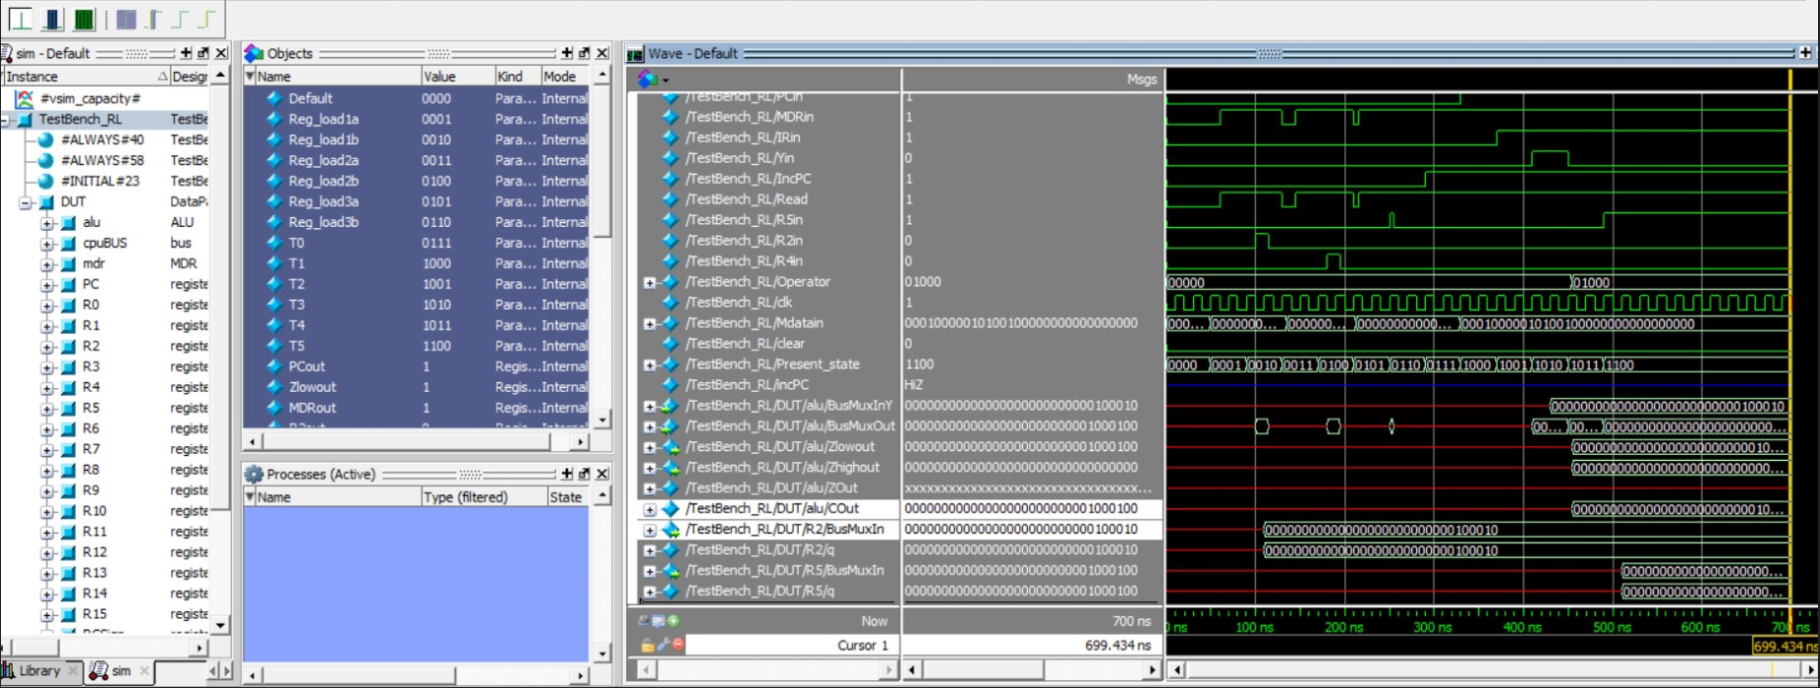

## Not Operation

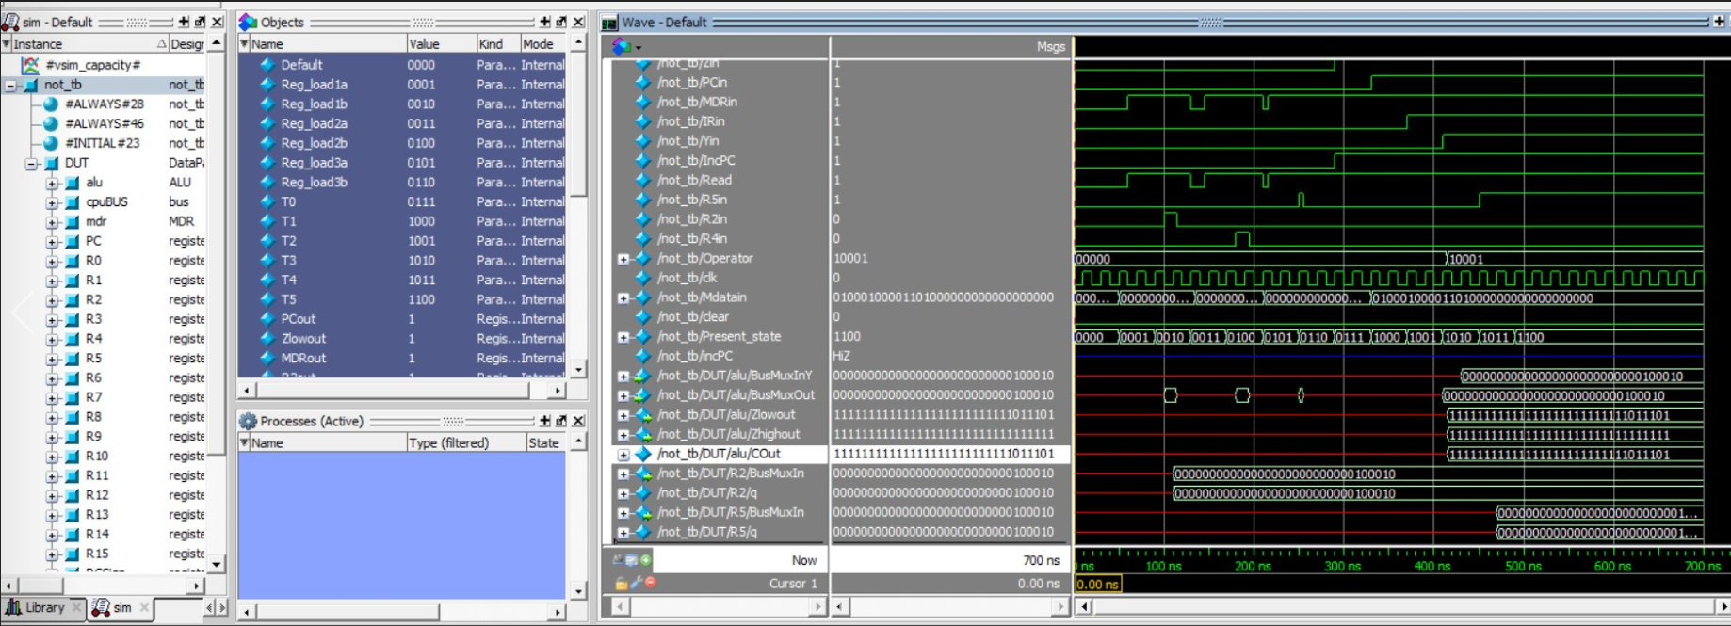

## Negate Operation

